LinkedIn Posts Automation
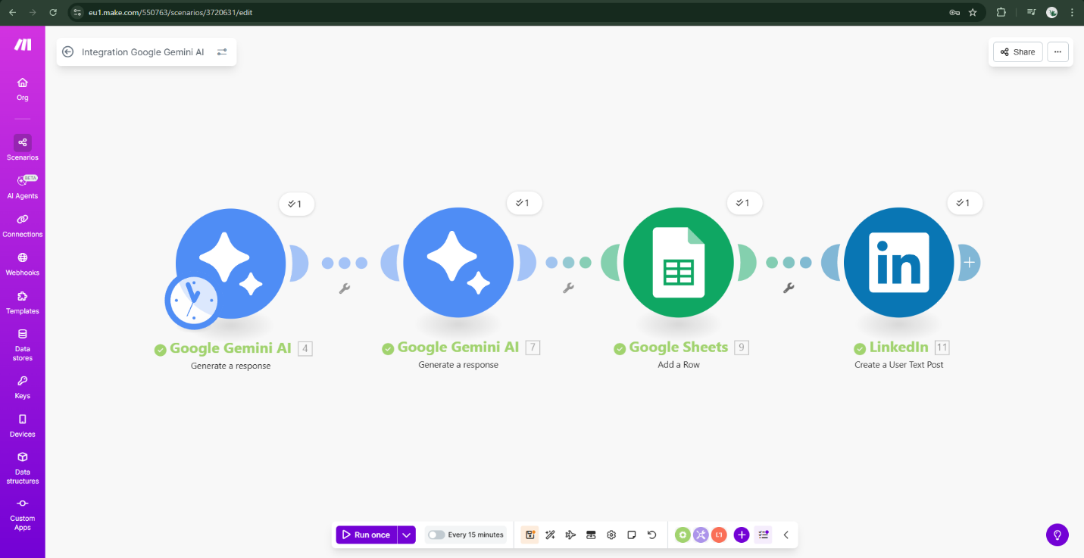
Fares Ahmed Moustafa
Scenario

Google Sheet Link
Ideas Google Sheet

LinkedIn Post Link
Post

